Visoka škola strukovnih studija za informacione i komunikacione tehnologije



# Dokumentacija

<http://shopedia-belgrade.000webhostapp.com>

Nikola Nedeljković 2/17

# Sadržaj

Dokumentacija 1

Sadržaj 2

1. UVOD 4

1.1 Korišćeni programski / markap jezici 4

1.2 Opis funkcionalnosti 4

1.3 Izgled stranica 7

2. ORGANIZACIJA 8

2.1 Organizacija sajta 8

**1.** 9

2.2 Organizacija baze 9

2.3 Sitemap.xml 10

2.4 Slike stranica sa funkcionalnostima 11

3. KODOVI 17

3.1 index.php 17

3.2. api.php 🡪 komunikacija između index i kontrolera 18

3.3. data.php 🡪 dohvatanje podataka za prikaz 19

3.4 autoload.php 20

3.5. DATABASE.php 🡪 SQL upiti i kreiranje baze 20

3.6 ItemController.php 21

3.7 LoginController.php 22

3.8. MeasureController.php 23

3.9 RegisterController.php 24

3.10 RoleController.php 24

3.11. ShopController.php 25

3.12 UserController.php 26

3.13. Item.php 26

3.14. Measure.php 27

3.15. Role.php 28

3.16. Shop.php 28

3.17. User.php 28

3.18. footer.php 29

3.19. header.php 30

3.20. 404.php 31

3.21. admin.php 31

3.22. login.php 32

3.23. main.php 33

3.24. register.php 35

3.25. teacher.php 35

3.26. style.css 36

3.27. main.js 44

4. HIJERARHIJSKI PREGLED 48

# UVOD

## Korišćeni programski / markap jezici

* Za izradu ovog sajta korišćene su sledeće tehnologije:
* Mark-up jezici: HTML 5, XML
* CSS3
* Skripting-programski jezici: JavaScript, PHP
* Sajt je napisan u Atom-u

## Opis funkcionalnosti

* **index.php**
* Dinamičko učitavanje stranica po stanju korisnika i odabranom linku
* **api.php**
* Komunikacija između indexa i kontrolora
* **data.php**
* Stranica za dohvatanje podataka koji treba da se prikažu na stranici
* **app/Config/autoload.php**
* Autoload skripta
* **app/Config/config.php**
* Promenljive za povezivanje na bazu
* **app/Config/DATABASE.php**
* Klasa baze podataka
* Inicijalizacija i izvršavanje upita
* **app/Controllers/ItemController.php**
* Klasa ItemController
* Inicijalizacija i rad sa podacima za tabelu item
* **app/Controllers/LoginController.php**
* Klasa LoginController
* Inicijalizacija i rad sa podacima za logovanje korisnika
* **app/Controllers/MeasureController.php**
* Klasa MeasureController
* Inicijalizacija i rad sa podacima za tabelu measure
* **app/Controllers/RegisterController.php**
* Klasa RegisterController
* Inicijalizacija i rad sa podacima za registraciju korisnika
* **app/Controllers/RoleController.php**
* Klasa RoleController
* Inicijalizacija i rad sa podacima za tabelu role
* **app/Controllers/ShopController.php**
* Klasa ShopController
* Inicijalizacija i rad sa podacima za tabelu shop
* **app/Controllers/UserController.php**
* Klasa UserController
* Inicijalizacija i rad sa podacima za tabelu user
* **app/Models/Item.php**
* Klasa Item
* Inicijalizacija i rad sa tabelom item
* **app/Models/Measure.php**
* Klasa Measure
* Inicijalizacija i rad sa tabelom measure
* **app/Models/Role.php**
* Klasa Role
* Inicijalizacija i rad sa tabelom role
* **app/Models/Shop.php**
* Klasa Shop
* Inicijalizacija i rad sa tabelom shop
* **app/Models/User.php**
* Klasa User
* Inicijalizacija i rad sa tabelom user
* **app/Views/fixed/footer.php**
* Dinamički prikaz linkova i copyright
* **app/Views/fixed/header.php**
* Head tag
* Logo
* Dinamički prikaz log in/log out dugmića
* **app/Views/pages/404.php**
* Error stranica
* **app/Views/pages/admin.php**
* Prikaz admin stranice
* Funkcionalnosti vezane samo za admin naloge
* **app/Views/pages/login.php**
* Prikaz login stranice
* Logovanje korisnika
* **app/Views/pages/main.php**
* Glavna stranica korisnika
* Prikaz, dodavanje i izmena podataka iz šoping liste
* Prikaz, dodavanje i izmena radnji u kojima korisnik kupuje
* **app/Views/pages/register.php**
* Prikaz register stranice
* Registracija korisnika
* **app/Views/pages/teacher.php**
* Prikaz stranice o autoru

## Izgled stranica

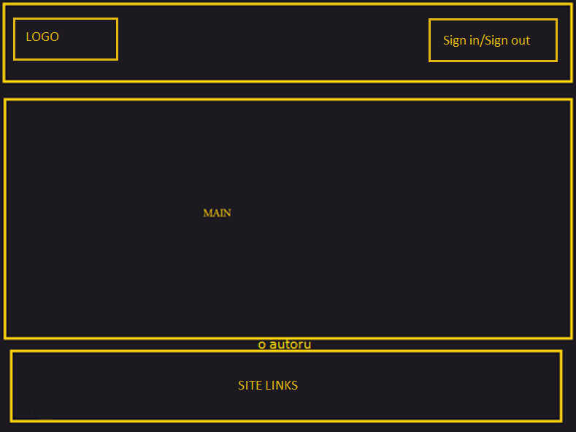

# ORGANIZACIJA

## Organizacija sajta

1. 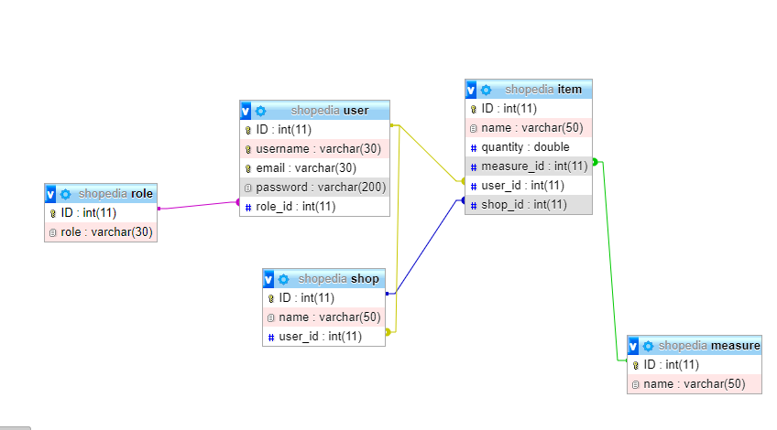

## Organizacija baze



## Sitemap.xml

<?xml version="1.0"?>

<urlset xlmns="http://www.sitemaps.org/schemas/sitemap/0.9">

<url>

<loc>https://shopedia-belgrade.000webhostapp.com/index.php</loc>

<lastmod>2020-02-11</lastmod>

<changefreq>daily</changefreq>

<priority>1</priority>

</url>

</urlset>



## Slike stranica sa funkcionalnostima

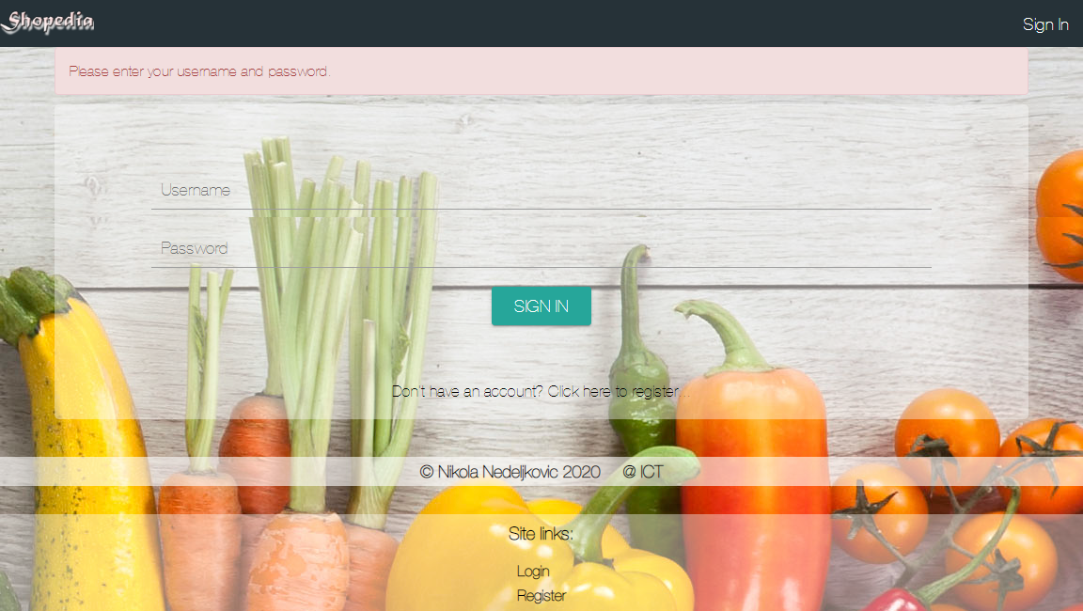

login.php

* Ispisivanje login forme, korisnička provera unetih podataka, prosleđivanje na kontroler i dalja obrada toga. Redirekcija na osnovu dobijenih parametara. Sajtu se ne može pristupiti bez prvog logovanja.

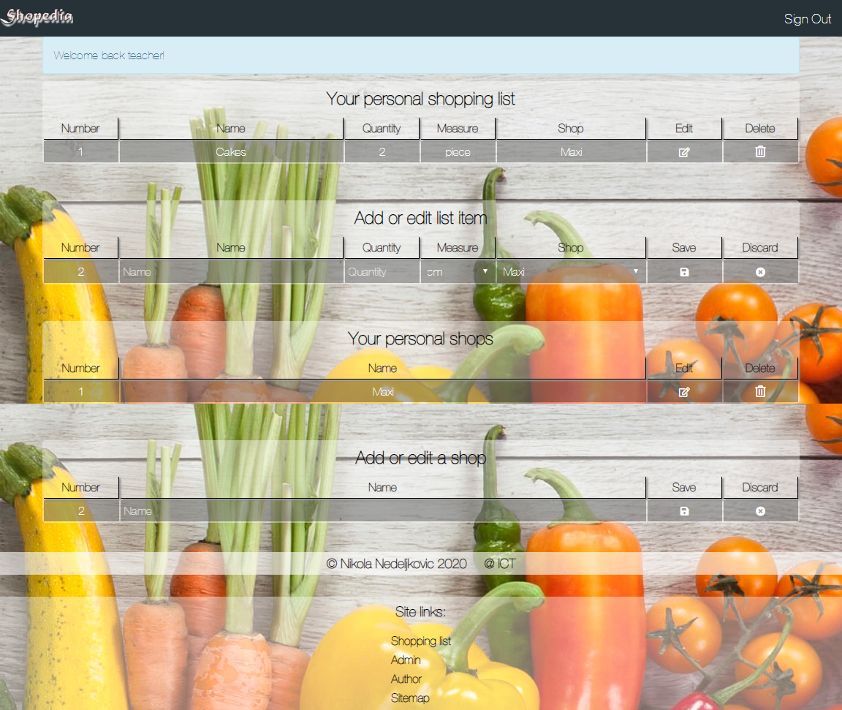

main.php

* Dinamičko ispisivanje podataka i korisnička obrada novih i starih fajlova pred slanje na kontroler

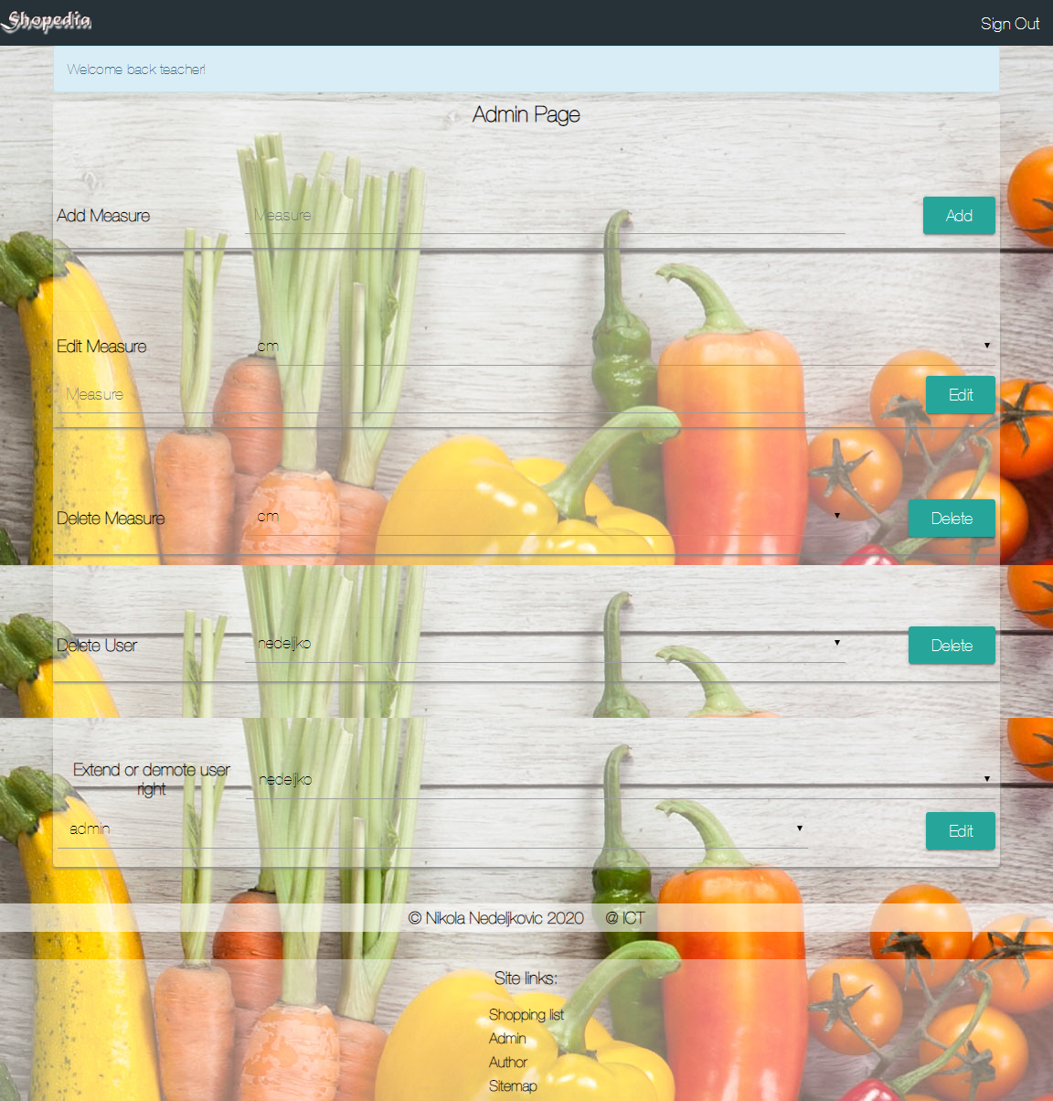

admin.php

* Dinamičko ispisivanje podataka i korisnička obrada novih i starih fajlova pred slanje na kontroler. Kontrole kojima samo admin može pristupiti.

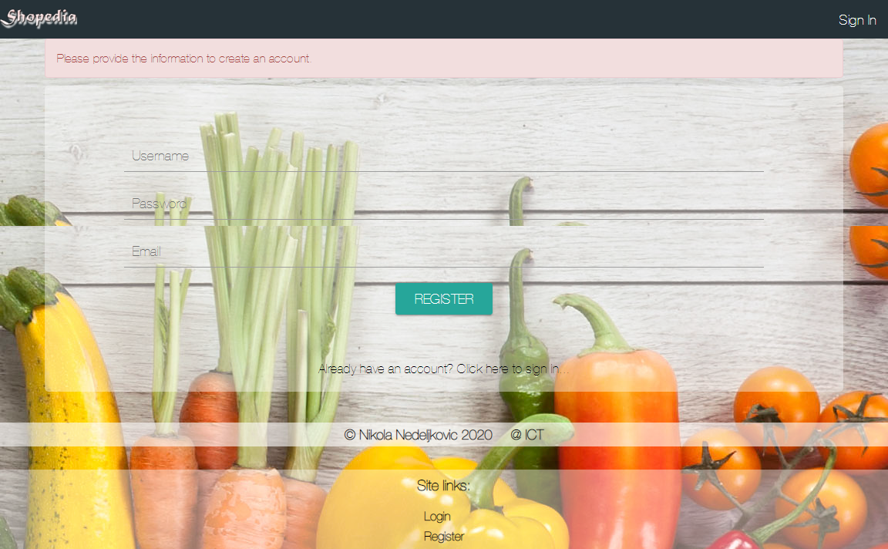

register.php

* Ispisivanje forme za registraciju, korisnička provera unetih podataka, prosleđivanje na kontroler i dalja obrada toga. Redirekcija na osnovu dobijenih parametara.

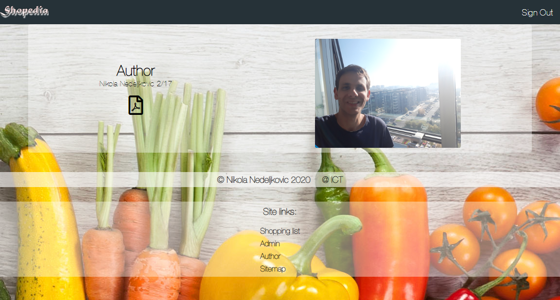

teacher.php

* Stranica o autoru.

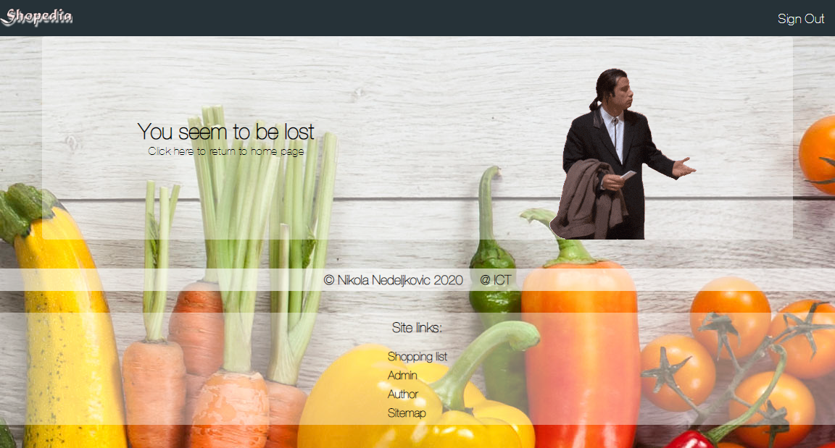

404.php

* 404 stranica za greške.

# KODOVI

## index.php

<?php

**session_start**();

**include**("app/Views/fixed/header.php");

**if** (**isset**($_GET["page"])) {

**switch**($_GET["page"]) {

**case** "login":

**if**(**isset**($_SESSION['user'])) {

**include** "app/Views/pages/main.php";

} **else** {

**include** "app/Views/pages/login.php";

}

**break**;

**case** "register":

**if**(**isset**($_SESSION['user'])) {

**include** "app/Views/pages/main.php";

} **else** {

**include** "app/Views/pages/register.php";

}

**break**;

**case** "main":

**include** "app/Views/pages/main.php";

**break**;

**case** "admin":

**if**(**isset**($_SESSION['user'])) {

**if** (($_SESSION['user']->role_id != 1) && ($_SESSION['user']->role_id != 3)) {

**include** "app/Views/pages/main.php";

} **else** {

**include** "app/Views/pages/admin.php";

}

} **else** {

**include** "app/Views/pages/login.php";

}

**break**;

**case** "teacher":

**if**(**isset**($_SESSION['user'])) {

**if** ($_SESSION['user']->role_id != 3) {

**include** "app/Views/pages/main.php";

} **else** {

**include** "app/Views/pages/teacher.php";

}

} **else** {

**include** "app/Views/pages/login.php";

}

**break**;

**default**:

**include** "app/Views/pages/404.php";

**break**;

}

} **else** {

**if**(!**isset**($_SESSION['user'])) {

**include** "app/Views/pages/login.php";

} **else** {

**include** "app/Views/pages/main.php";

}

}

**include**("app/Views/fixed/footer.php");

?>



## api.php 🡪 komunikacija između index i kontrolera

<?php

**require_once** "app/Config/autoload.php";

**require** "app/Config/config.php";

**use** App\Controllers\LoginController;

**use** App\Controllers\RegisterController;

**use** App\Controllers\ShopController;

**use** App\Controllers\UserController;

**use** App\Controllers\MeasureController;

**use** App\Controllers\ItemController;

$login = **new** LoginController();

$register = **new** RegisterController();

$shopcont = **new** ShopController();

$usercont = **new** UserController();

$measurecont = **new** MeasureController();

$itemcont = **new** ItemController();

**session_start**();

**function** logFunction ($content) {

$log_path = $_SERVER["DOCUMENT_ROOT"] . "/data/log.txt";

$open = **fopen**($log_path, "a");

**if** ($open && **isset**($_SESSION["user"])) {

$date = **date**('d-m-Y H:i:s');

**fwrite**($open, "{$content}\t{$date}\t{$_SESSION['user']->username}\t\n");

**fclose**($open);

}

}

logFunction($_GET['page']);

**switch** ($_GET['page']) {

**case** 'login':

$login->login($_POST);

**break**;

**case** 'logout':

**if**(**isset**($_SESSION['user'])) {

**unset**($_SESSION['user']);

**session_destroy**();

}

**header**("Location: index.php?page=login");

**die**();

**break**;

**case** 'register':

$register->register($_POST);

**break**;

**case** 'shop_edit':

**if** ($_POST["shop_add_edit_id"] != "") {

$shopcont->updateShop($_POST);

} **else** {

$shopcont->addShop($_POST, $_SESSION['user']->ID);

}

**break**;

**case** 'shop_delete':

$shopcont->deleteShop($_GET['id']);

**break**;

**case** 'item_edit':

**if** ($_POST["item_add_edit_id"] != "") {

$itemcont->updateItem($_POST, $_SESSION['user']->ID);

} **else** {

$itemcont->addItem($_POST, $_SESSION['user']->ID);

}

**break**;

**case** 'item_delete':

$itemcont->deleteItem($_GET['id']);

**break**;

**case** 'add_measure':

$measurecont->addMeasure($_POST);

**break**;

**case** 'edit_measure':

$measurecont->updateMeasure($_POST);

**break**;

**case** 'delete_measure':

$measurecont->deleteMeasure($_POST);

**break**;

**case** 'edit_user':

$usercont->editUserRight($_POST);

**break**;

**case** 'delete_user':

$usercont->deleteUser($_POST);

**break**;

**default**:

**header**("Location: index.php?page=main");

**die**();

**break**;

}

?>

## data.php 🡪 dohvatanje podataka za prikaz

<?php

**require_once** "app/Config/autoload.php";

**require** "app/Config/config.php";

**use** App\Controllers\ShopController;

**use** App\Controllers\RoleController;

**use** App\Controllers\UserController;

**use** App\Controllers\MeasureController;

**use** App\Controllers\ItemController;

$shopcont = **new** ShopController();

$rolecont = **new** RoleController();

$usercont = **new** UserController();

$measurecont = **new** MeasureController();

$itemcont = **new** ItemController();

$item_data = $itemcont->getItems($_SESSION['user']->ID);

$measure_data = $measurecont->getMeasures();

$shop_data = $shopcont->getShops($_SESSION['user']->ID);

$user_data = $usercont->getUsers($_SESSION['user']->ID);

$role_data = $rolecont->getRoles();

?>



## autoload.php

<?php

// AUTOLOAD

**spl_autoload_register**(**function** ($path) {

$path = **str_replace**("\\", **DIRECTORY_SEPARATOR**, $path);

$path[0] = **strtolower**($path[0]);

$path .= ".php";

**require_once** $path;

});



## DATABASE.php 🡪 SQL upiti i kreiranje baze

<?php

**namespace** App\Config;

**class** DATABASE {

**private** $connection;

**private** **static** $database;

**private** **function** **__construct**() {

$this->connect();

}

**public** **static** **function** instance() {

**if**(self::$database === **null**){

self::$database = **new** DATABASE();

}

**return** self::$database;

}

**private** **function** connect() {

**try** {

$this->connection = **new** \PDO("mysql:host=".SERVER.";dbname=".DBNAME.";charset=utf8", USERNAME, PASSWORD);

$this->connection->setAttribute(\PDO::ATTR_DEFAULT_FETCH_MODE, \PDO::FETCH_OBJ);

$this->connection->setAttribute(\PDO::ATTR_ERRMODE, \PDO::ERRMODE_EXCEPTION);

}

**catch**(PDOException $ex) {

**echo** $ex->getMessage();

}

}

**public** **function** executeQuery(**string** $query) {

**return** $this->connection->query($query)->fetchAll();

}

**public** **function** executeQueryAll(**string** $query, **Array** $params) {

$prepare = $this->connection->prepare($query);

$prepare->execute($params);

**return** $prepare->fetchAll();

}

**public** **function** executeQueryOneRow(**string** $query, **Array** $params) {

$prepare = $this->connection->prepare($query);

$prepare->execute($params);

**return** $prepare->fetch();

}

**public** **function** executeInsert(**string** $query, **Array** $params) {

$prepare = $this->connection->prepare($query);

$prepare->execute($params);

}

**public** **function** executeUpdate(**string** $query, **Array** $params) {

$prepare = $this->connection->prepare($query);

$prepare->execute($params);

}

**public** **function** executeDelete(**string** $query, **Array** $params) {

$prepare = $this->connection->prepare($query);

$prepare->execute($params);

}

}



## ItemController.php

<?php

**namespace** App\Controllers;

**use** App\Models\Item;

**use** App\Config\DATABASE;

**class** ItemController {

**private** $model;

**public** **function** **__construct**(){

$this->model = **new** Item(DATABASE::instance());

}

**public** **function** getItems($user_id) {

**return** $this->model->getItems($user_id);

}

**public** **function** addItem($request, $user_id) {

**if**(**isset**($request['item_add_edit_submit'])) {

$name = $request['item_add_edit_name'];

$quantity = $request['item_add_edit_quantity'];

$measure = $request['item_add_edit_measure'];

$shop = $request['item_add_edit_shop'];

**if** ($name != "" && $quantity != "" && $measure != "" && $shop != "") {

$this->model->addItem($name, $quantity, $measure, $user_id, $shop);

}

}

**header**("Location: index.php?page=main");

}

**public** **function** updateItem($request) {

**if**(**isset**($request['item_add_edit_submit'])) {

$name = $request['item_add_edit_name'];

$id = $request['item_add_edit_id'];

$quantity = $request['item_add_edit_quantity'];

$measure = $request['item_add_edit_measure'];

$shop = $request['item_add_edit_shop'];

**if** ($name != "" && $quantity != "" && $measure != "" && $shop != "") {

$this->model->updateItem($name, $quantity, $measure, $shop, $id);

}

}

**header**("Location: index.php?page=main");

}

**public** **function** deleteItem($id) {

$this->model->deleteItem($id);

**header**("Location: index.php?page=main");

}

}



## LoginController.php

<?php

**namespace** App\Controllers;

**use** App\Models\User;

**use** App\Config\DATABASE;

**class** LoginController {

**private** $model;

**public** **function** **__construct**(){

$this->model = **new** User(DATABASE::instance());

}

**public** **function** login($request) {

**if**(**isset**($request['signin'])) {

$username = $request['username'];

$password = $request['password'];

$user = $this->model->getUser($username, $password);

**if**($user) {

$_SESSION['user'] = $user;

} **else** {

$_SESSION['l_error'] ="User not registered or wrong credentials!";

}

**header**("Location: index.php?page=login");

} **else** {

\**http_response_code**(404);

}

}

}



## MeasureController.php

<?php

**namespace** App\Controllers;

**use** App\Models\Measure;

**use** App\Config\DATABASE;

**class** MeasureController {

**private** $model;

**public** **function** **__construct**(){

$this->model = **new** Measure(DATABASE::instance());

}

**public** **function** getMeasures() {

**return** $this->model->getMeasures();

}

**public** **function** addMeasure($request) {

**if**(**isset**($request['submit_add_measure'])) {

$name = $request['add_measure'];

**if** ($name != "") {

$this->model->addMeasure($name);

}

}

**header**("Location: index.php?page=admin");

}

**public** **function** updateMeasure($request) {

**if**(**isset**($request['submit_edit_measure'])) {

$name = $request['edit_measure'];

$id = $request['edit_measure_id'];

**if** ($name != "") {

$this->model->updateMeasure($name, $id);

}

}

**header**("Location: index.php?page=admin");

}

**public** **function** deleteMeasure($request) {

**if**(**isset**($request['submit_delete_measure'])) {

$id = $request['measure_delete_select'];

**if** ($id != "") {

$this->model->deleteMeasure($id);

}

}

**header**("Location: index.php?page=admin");

}

}



## RegisterController.php

<?php  
 **namespace** App\Controllers;

**use** App\Models\User;

**use** App\Config\DATABASE;

**class** RegisterController {

**private** $model;

**public** **function** **__construct**(){

$this->model = **new** User(DATABASE::instance());

}

**public** **function** register($request) {

**if**(**isset**($request['register'])) {

$username = $request['username'];

$password = $request['password'];

$email = $request['email'];

**if**(!**filter_var**($email, **FILTER_VALIDATE_EMAIL**)) {

$_SESSION['r_error']= "Email not valid!";

}

**else** {

$user = $this->model->existsUser($username, $email);

**if**($user) {

$_SESSION['r_error'] ="Email or username already in use!";

} **else** {

$this->model->createUser($username, $email, $password);

$_SESSION['r_error'] ="User created successfully, you can now login with your credentials!";

}

}

**header**("Location: index.php?page=register");

} **else** {

\**http_response_code**(404);

}

}

}



## RoleController.php

<?php

**namespace** App\Controllers;

**use** App\Models\Role;

**use** App\Config\DATABASE;

**class** RoleController {

**private** $model;

**public** **function** **__construct**(){

$this->model = **new** Role(DATABASE::instance());

}

**public** **function** getRoles() {

**return** $this->model->getRoles();

}

}



## ShopController.php

<?php

**namespace** App\Controllers;

**use** App\Models\Shop;

**use** App\Config\DATABASE;

**class** ShopController {

**private** $model;

**public** **function** **__construct**(){

$this->model = **new** Shop(DATABASE::instance());

}

**public** **function** getShops($user_id) {

**return** $this->model->getShops($user_id);

}

**public** **function** addShop($request, $user_id) {

**if**(**isset**($request['shop_add_edit_submit'])) {

$name = $request['shop_add_edit_name'];

**if** ($name != "") {

$this->model->addShop($name, $user_id);

}

}

**header**("Location: index.php?page=main");

}

**public** **function** updateShop($request) {

**if**(**isset**($request['shop_add_edit_submit'])) {

$name = $request['shop_add_edit_name'];

$id = $request['shop_add_edit_id'];

**if** ($name != "") {

$this->model->updateShop($name, $id);

}

}

**header**("Location: index.php?page=main");

}

**public** **function** deleteShop($id) {

$this->model->deleteShop($id);

**header**("Location: index.php?page=main");

}

}



## UserController.php

<?php

**namespace** App\Controllers;

**use** App\Models\User;

**use** App\Config\DATABASE;

**class** UserController {

**private** $model;

**public** **function** **__construct**(){

$this->model = **new** User(DATABASE::instance());

}

**public** **function** getUsers($id) {

**return** $this->model->getUsers($id);

}

**public** **function** editUserRight($request) {

**if**(**isset**($request['submit_edit_user_id'])) {

$user = $request['edit_user_right_id'];

$role = $request['user_right_select'];

**if** ($user != "" && $role != "") {

$this->model->editUserRight($role, $user);

}

}

**header**("Location: index.php?page=admin");

}

**public** **function** deleteUser($request) {

**if**(**isset**($request['submit_delete_user'])) {

$id = $request['user_delete_select'];

**if** ($id != "") {

$this->model->deleteUser($id);

}

}

**header**("Location: index.php?page=admin");

}

}



## Item.php

<?php

**namespace** App\Models;

**use** App\Config\DATABASE;

**class** Item {

**private** $database;

**public** **function** **__construct**(DATABASE $database) {

$this->database = $database;

}

**public** **function** getItems($user_id) {

**return** $this->database->executeQueryAll("SELECT i.ID as item_id, i.name AS name, i.quantity AS quantity, m.name AS measure, s.name AS shop, m.ID AS measure_id, s.ID AS shop_id FROM item i INNER JOIN measure m ON i.measure_id = m.ID INNER JOIN shop s ON i.shop_id = s.ID WHERE i.user_id = ?", [$user_id]);

}

**public** **function** addItem($name, $quantity, $measure, $user_id, $shop) {

$this->database->executeInsert("INSERT INTO item (name, quantity, measure_id, user_id, shop_id) VALUES (?, ?, ?, ?, ?)", [$name, $quantity, $measure, $user_id, $shop]);

}

**public** **function** updateItem($name, $quantity, $measure, $shop, $id) {

$this->database->executeUpdate("UPDATE item SET name = ?, quantity = ?, measure_id = ?, shop_id = ? WHERE ID = ?", [$name, $quantity, $measure, $shop, $id]);

}

**public** **function** deleteItem($id) {

$this->database->executeDelete("DELETE FROM item WHERE ID = ?", [$id]);

}

}



## Measure.php

<?php

**namespace** App\Models;

**use** App\Config\DATABASE;

**class** Measure {

**private** $database;

**public** **function** **__construct**(DATABASE $database) {

$this->database = $database;

}

**public** **function** getMeasures() {

**return** $this->database->executeQuery("SELECT * FROM measure");

}

**public** **function** addMeasure($name) {

$this->database->executeInsert("INSERT INTO measure (name) VALUES (?)", [$name]);

}

**public** **function** updateMeasure($name, $id) {

$this->database->executeUpdate("UPDATE measure SET name = ? WHERE ID = ?", [$name, $id]);

}

**public** **function** deleteMeasure($id) {

$this->database->executeDelete("DELETE FROM measure WHERE ID = ?", [$id]);

}

}



## Role.php

<?php

**namespace** App\Models;

**use** App\Config\DATABASE;

**class** Role {

**private** $database;

**public** **function** **__construct**(DATABASE $database) {

$this->database = $database;

}

**public** **function** getRoles() {

**return** $this->database->executeQuery("SELECT * FROM role");

}

}



## Shop.php

<?php

**namespace** App\Models;

**use** App\Config\DATABASE;

**class** Shop {

**private** $database;

**public** **function** **__construct**(DATABASE $database) {

$this->database = $database;

}

**public** **function** getShops($user_id) {

**return** $this->database->executeQueryAll("SELECT ID, name FROM shop WHERE user_id = ?", [$user_id]);

}

**public** **function** addShop($name, $user_id) {

$this->database->executeInsert("INSERT INTO shop (name, user_id) VALUES (?, ?)", [$name, $user_id]);

}

**public** **function** updateShop($name, $id) {

$this->database->executeUpdate("UPDATE shop SET name = ? WHERE ID = ?", [$name, $id]);

}

**public** **function** deleteShop($id) {

$this->database->executeDelete("DELETE FROM shop WHERE ID = ?", [$id]);

}

}



## User.php

<?php

**namespace** App\Models;

**use** App\Config\DATABASE;

**class** User {

**private** $database;

**public** **function** **__construct**(DATABASE $database) {

$this->database = $database;

}

**public** **function** getUsers($id) {

**return** $this->database->executeQueryAll("SELECT ID, username, role_id FROM user WHERE ID != ?", [$id]);

}

**public** **function** getUser($username, $password) {

**return** $this->database->executeQueryOneRow("SELECT ID, username, email, role_id FROM user WHERE username = ? AND password=MD5(?)", [$username, $password]);

}

**public** **function** existsUser($username, $email) {

**return** $this->database->executeQueryOneRow("SELECT username, email, role_id FROM user WHERE username = ? OR email = ?", [$username, $email]);

}

**public** **function** createUser($username, $email, $password) {

$this->database->executeInsert("INSERT INTO user(username, email, password, role_id) VALUES (?, ?, MD5(?), 2)", [$username, $email, $password]);

}

**public** **function** editUserRight($role, $user) {

$this->database->executeUpdate("UPDATE user SET role_id = ? WHERE ID = ?", [$role, $user]);

}

**public** **function** deleteUser($id) {

$this->database->executeDelete("DELETE FROM user WHERE ID = ?", [$id]);

}

}

## footer.php

<div class=**"footer_panel"**>

<p><a href=**"**https://www.linkedin.com/in/nikola-nedeljkovic-8110b5150**"**>*&copy;* **Nikola Nedeljkovic 2020** *&nbsp;&nbsp;&nbsp;* **@ ICT**</a></p>

<div class=**"site_links"**>

<h3>**Site links:**</h3>

<ul>

<?php

**if**(**isset**($_SESSION['user'])) {

**echo** "<li><a href=\"index.php?page=main\">Shopping list</a></li>";

**if** (($_SESSION['user']->role_id == 1) || ($_SESSION['user']->role_id == 3)) {

**echo** "<li><a href=\"index.php?page=admin\">Admin</a></li>";

}

**if** ($_SESSION['user']->role_id == 3) {

**echo** "<li><a href=\"index.php?page=teacher\">Author</a></li>";

**echo** "<li><a href=\"sitemap.xml\">Sitemap</a></li>";

}

} **else** {

**echo** "<li><a href=\"index.php?page=login\">Login</a></li>";

**echo** "<li><a href=\"index.php?page=register\">Register</a></li>";

}

?>

</ul>

</div>

</div>

</body>

<script type=**"text/javascript"** src=**"assets/js/main.js"**></script>

</html>



## header.php

<!DOCTYPE html>

<html>

<head>

<title>**Shopedia**</title>

<meta name=**"viewport"** content=**"width=device-width, initial-scale=1.0"**/>

<meta name=**"author"** content=**"Nikola Nedeljkovic"**/>

<meta name=**"copyright"** content=**"RarOks 1008 Entertainment @ 2020"**/>

<meta name=**"robots"** content=**"index,follow"**/>

<meta name=**"keywords"** content=**"shopping, list, grocery"**/>

<meta name=**"description"** content=**"Here you can add your own shopping list and use it from all devices."**/>

<meta name=**"abstract"** content=**"Shop with Shopedia."**/>

<link rel=**"shortcut icon"** href=**"favicon.ico"**/>

<link rel=**"stylesheet"** href=**"**https://use.fontawesome.com/releases/v5.8.1/css/all.css**"** integrity=**"sha384-50oBUHEmvpQ+1lW4y57PTFmhCaXp0ML5d60M1M7uH2+nqUivzIebhndOJK28anvf"** crossorigin=**"anonymous"**/>

<link rel=**"stylesheet"** href=**"assets/css/style.css"**/>

</head>

<body>

<div class=**"header_holder"**>

<a href=**"index.php?page=main"**>

<h1>**Shopedia**</h1>

</a>

<?php **if**(**isset**($_SESSION["user"])) : ?>

<a href=**"api.php?page=logout"** class=**"login_logout_button"**>**Sign Out**</a>

<?php **else** : ?>

<a href=**"index.php?page=login"** class=**"login_logout_button"**>**Sign In**</a>

<?php **endif**; ?>

</div>



## 404.php

<div class=**"fourofour"**>

<div class=**"lost_text"**>

<h2>**You seem to be lost**</h2>

<a href=**"index.php?page=main"**>**Click here to return to home page**</a>

</div>

<img src=**"assets/img/travolta.gif"** alt=**"Lost"**/>

</div>



## admin.php

<?php **include_once** "data.php"; ?>

<p id=**"welcome_sign"**>**Welcome back** <?php **echo** $_SESSION['user']->username; ?>**!**</p>

<div class=**"admin_panel"**>

<h2>**Admin Page**</h2>

<div class=**"admin_item"**>

<h3>**Add Measure**</h3>

<form onsubmit=**"return add_measure_check()"** method=**"POST"** action=**"api.php?page=add_measure"**>

<input type=**"text"** name=**"add_measure"** id=**"add_measure"** Placeholder=**"Measure"**/>

<button type=**"submit"** name=**"submit_add_measure"**>**Add**</button>

</form>

</div>

<div class=**"admin_item with_more"**>

<div class=**"more_admin_options"**>

<h3>**Edit Measure**</h3>

<select id=**"measure_edit_select"** onchange=**"admin_measure_change()"**>

<?php **foreach**($measure_data **as** $measure): ?>

<option value=**"**<?=$measure->ID;?>**"**><?=$measure->name;?></option>

<?php **endforeach**; ?>

</select>

</div>

<form class=**"more_admin_options"** onsubmit=**"return edit_measure_check()"** method=**"POST"** action=**"api.php?page=edit_measure"**>

<input type=**"hidden"** name=**"edit_measure_id"** id=**"edit_measure_id"**/>

<input type=**"text"** name=**"edit_measure"** id=**"edit_measure"** Placeholder=**"Measure"**/>

<button type=**"submit"** name=**"submit_edit_measure"**>**Edit**</button>

</form>

</div>

<div class=**"admin_item"**>

<h3>**Delete Measure**</h3>

<form onsubmit=**"return delete_measure_check()"** method=**"POST"** action=**"api.php?page=delete_measure"**>

<select id=**"measure_delete_select"** name=**"measure_delete_select"**>

<?php **foreach**($measure_data **as** $measure): ?>

<option value=**"**<?=$measure->ID;?>**"**><?=$measure->name;?></option>

<?php **endforeach**; ?>

</select>

<button type=**"submit"** name=**"submit_delete_measure"**>**Delete**</button>

</form>

</div>

<div class=**"admin_item"**>

<h3>**Delete User**</h3>

<form method=**"POST"** action=**"api.php?page=delete_user"**>

<select id=**"user_delete_select"** name=**"user_delete_select"**>

<?php **foreach**($user_data **as** $user): ?>

<option value=**"**<?=$user->ID;?>**"**><?=$user->username;?></option>

<?php **endforeach**; ?>

</select>

<button type=**"submit"** name=**"submit_delete_user"**>**Delete**</button>

</form>

</div>

<div class=**"admin_item with_more"**>

<div class=**"more_admin_options"**>

<h3>**Extend or demote user right**</h3>

<select id=**"user_change_select"** onchange=**"admin_user_change()"**>

<?php **foreach**($user_data **as** $user): ?>

<option value=**"**<?=$user->ID;?>**"** data-id=**"**<?=$user->role_id;?>**"**><?=$user->username;?></option>

<?php **endforeach**; ?>

</select>

</div>

<form class=**"more_admin_options"** onsubmit=**"return edit_user_check()"** method=**"POST"** action=**"api.php?page=edit_user"**>

<input type=**"hidden"** name=**"edit_user_right_id"** id=**"edit_user_right_id"**/>

<select id=**"user_right_select"** name=**"user_right_select"**>

<?php **foreach**($role_data **as** $role): ?>

<option value=**"**<?=$role->ID;?>**"**><?=$role->role;?></option>

<?php **endforeach**; ?>

</select>

<button type=**"submit"** name=**"submit_edit_user_id"**>**Edit**</button>

</div>

</div>

</div>



## login.php

<p id=**"login_error"**><?php

**if**(**isset**($_SESSION['l_error'])) {

**echo** $_SESSION['l_error'];

} **else** {

**echo** "Please enter your username and password.";

} ?></p>

<div class=**"login_panel"**>

<form onsubmit=**"return login_check()"** method=**"POST"** action=**"api.php?page=login"**>

<input type=**"text"** name=**"username"** id=**"username"** placeholder=**"Username"**/>

<input type=**"password"** name=**"password"** id=**"password"** placeholder=**"Password"**/>

<button type=**"submit"** name=**"signin"** id=**"signin"**>**SIGN IN**</button>

</form>

<a href=**"index.php?page=register"**>**Don't have an account? Click here to register...**</a>

</div>



## main.php

<?php **include_once** "data.php"; ?>

<p id=**"welcome_sign"**>**Welcome back** <?php **echo** $_SESSION['user']->username; ?>**!**</p>

<div class=**"main_panel"**>

<h2>**Your personal shopping list**</h2>

<table>

<tr>

<th>**Number**</th>

<th>**Name**</th>

<th>**Quantity**</th>

<th>**Measure**</th>

<th>**Shop**</th>

<th>**Edit**</th>

<th>**Delete**</th>

</tr>

<?php $item_num = 1; **foreach**($item_data **as** $item): ?>

<tr>

<td id=**"itemnum**<?=$item_num;?>**"**><?=$item_num;?></td>

<td id=**"itemname**<?=$item_num;?>**"**><?=$item->name;?></td>

<td id=**"itemquantity**<?=$item_num;?>**"**><?=$item->quantity;?></td>

<td id=**"itemmeasure**<?=$item_num;?>**"** data-id=**"**<?=$item->measure_id;?>**"**><?=$item->measure;?></td>

<td id=**"itemshop**<?=$item_num;?>**"** data-id=**"**<?=$item->shop_id;?>**"**><?=$item->shop;?></td>

<td><button onclick=**"item_edit_click(**<?=$item_num;?>**,** <?=$item->item_id;?>**)"**><span class=**"far fa-edit"**></span></button></td>

<td><a href=**"api.php?page=item_delete&id=**<?=$item->item_id;?>**"**><span class=**"far fa-trash-alt"**></span></a></td>

</tr>

<?php $item_num++; **endforeach**; ?>

</table>

</div>

<div class=**"main_panel not_first"**>

<h2>**Add or edit list item**</h2>

<table>

<tr>

<th>**Number**</th>

<th>**Name**</th>

<th>**Quantity**</th>

<th>**Measure**</th>

<th>**Shop**</th>

<th>**Save**</th>

<th>**Discard**</th>

</tr>

<tr>

<form onsubmit=**"return add_edit_item_check()"** method=**"POST"** action=**"api.php?page=item_edit"**>

<input type=**"hidden"** name=**"item_add_edit_id"** id=**"item_add_edit_id"** value=**""**/>

<td id=**"item_add_edit_number"** data-id=**"**<?=$item_num;?>**"**><?=$item_num;?></td>

<td><input type=**"text"** name=**"item_add_edit_name"** id=**"item_add_edit_name"** placeholder=**"Name"**/></td>

<td><input type=**"number"** name=**"item_add_edit_quantity"** id=**"item_add_edit_quantity"** placeholder=**"Quantity"** min=**"1"**/></td>

<td><select name=**"item_add_edit_measure"** id=**"item_add_edit_measure"**>

<?php **foreach**($measure_data **as** $measure): ?>

<option value=**"**<?=$measure->ID;?>**"**><?=$measure->name;?></option>

<?php **endforeach**; ?>

</select></td>

<td><select name=**"item_add_edit_shop"** id=**"item_add_edit_shop"**>

<?php **foreach**($shop_data **as** $shops): ?>

<option value=**"**<?=$shops->ID;?>**"**><?=$shops->name;?></option>

<?php **endforeach**; ?>

</select></td>

<td><button type=**"submit"** name=**"item_add_edit_submit"**><span class=**"fas fa-save"**></span></button></td>

</form>

<td><button onclick=**"item_edit_discard()"**><span class=**"fas fa-times-circle"**></span></button></td>

</tr>

</table>

</div>

<div class=**"main_panel not_first your_shops"**>

<h2>**Your personal shops**</h2>

<table>

<tr>

<th>**Number**</th>

<th>**Name**</th>

<th>**Edit**</th>

<th>**Delete**</th>

</tr>

<?php $shop_num = 1; **foreach**($shop_data **as** $shop): ?>

<tr>

<td id=**"shopnum**<?=$shop_num;?>**"**><?=$shop_num;?></td>

<td id=**"shopname**<?=$shop_num;?>**"**><?=$shop->name;?></td>

<td><button onclick=**"shop_edit_click(**<?=$shop_num;?>**,** <?=$shop->ID;?>**)"**><span class=**"far fa-edit"**></span></button></td>

<td><a href=**"api.php?page=shop_delete&id=**<?=$shop->ID;?>**"**><span class=**"far fa-trash-alt"**></span></a></td>

</tr>

<?php $shop_num++; **endforeach**; ?>

</table>

</div>

<div class=**"main_panel not_first your_shops"**>

<h2>**Add or edit a shop**</h2>

<table>

<tr>

<th>**Number**</th>

<th>**Name**</th>

<th>**Save**</th>

<th>**Discard**</th>

</tr>

<tr>

<form onsubmit=**"return add_edit_shop_check()"** method=**"POST"** action=**"api.php?page=shop_edit"**>

<input type=**"hidden"** name=**"shop_add_edit_id"** id=**"shop_add_edit_id"** value=**""**/>

<td id=**"shop_add_edit_number"** data-id=**"**<?=$shop_num;?>**"**><?=$shop_num;?></td>

<td><input type=**"text"** name=**"shop_add_edit_name"** id=**"shop_add_edit_name"** placeholder=**"Name"**/></td>

<td><button type=**"submit"** name=**"shop_add_edit_submit"**><span class=**"fas fa-save"**></span></button></td>

</form>

<td><button onclick=**"shop_edit_discard()"**><span class=**"fas fa-times-circle"**></span></button></td>

</tr>

</table>

</div>



## register.php

<p id=**"register_error"**><?php

**if**(**isset**($_SESSION['r_error'])) {

**echo** $_SESSION['r_error'];

} **else** {

**echo** "Please provide the information to create an account.";

} ?></p>

<div class=**"register_panel"**>

<form onsubmit=**"return register_check()"** method=**"POST"** action=**"api.php?page=register"**>

<input type=**"text"** name=**"username"** id=**"username"** placeholder=**"Username"**/>

<input type=**"password"** name=**"password"** id=**"password"** placeholder=**"Password"**/>

<input type=**"email"** name=**"email"** id=**"email"** placeholder=**"Email"**/>

<button type=**"submit"** name=**"register"** id=**"register"**>**REGISTER**</button>

</form>

<a href=**"index.php?page=login"**>**Already have an account? Click here to sign in...**</a>

</div>



## teacher.php

<div class=**"teacher_panel"**>

<div class=**"teacher_text"**>

<h2>**Author**</h2>

<a href=**"**https://www.linkedin.com/in/nikola-nedeljkovic-8110b5150**"**>**Nikola Nedeljkovic 2/17**</a>

<div><a href=**"assets/documentation/documentation.pdf"**><span class=**"far fa-file-pdf"**></span></a></div>

</div>

<img src=**"assets/img/author.jpg"** alt=**"Author"**/>

</div>



## style.css

**@**font-face **{**

**font-family: HelveticaNeue;**

src**: url(../fonts/HelveticaNeue.ttf);**

**}**

* **{**

**margin: 0px;**

**padding: 0px;**

**box-sizing: border-box;**

**font-family: HelveticaNeue;**

**}**

html **{**

**background: url(**'../img/food_background.jpg'**) no-repeat center center fixed;**

**}**

h1 **{**

**width: 100px;**

**height: 50px;**

**background: url(**'../img/logo.png'**) top left no-repeat;**

**text-indent: -9999px;**

**background-size: cover;**

**color: #fff;**

**background-color: #263238;**

**}**

**.**red_border **{**

**border: 1px solid #f31413 !important;**

**border-radius: 3px;**

**}**

/*Header Stranica*/

**.**header_holder **{**

**width: 100%;**

**background-color: #263238;**

**display: flex;**

**justify-content: space-between;**

**align-items: center**

**}**

**.**header_holder a **{**

**color: #fff;**

**text-decoration: none;**

**}**

**.**header_holder **.**login_logout_button **{**

**font-size: 18px;**

**padding: 5px 15px;**

**}**

**.**header_holder **.**login_logout_button**:hover** **{**

**background-color: rgba(0,0,0,0.1);**

**color: #23527c;**

**}**

**@**media screen and (max-width: 200px) **{**

**.**header_holder **{**

**flex-direction: column;**

**}**

**.**header_holder **.**login_logout_button **{**

**margin-top: 5px;**

**margin-bottom: 5px;**

**}**

**}**

/*404 i Teacher Stranice*/

**.**fourofour**,** **.**teacher_panel **{**

**border-radius: 5px;**

**width: 90%;**

**margin-left: 5%;**

**background-color: rgba(255, 255, 255, 0.4);**

**display: flex;**

**justify-content: space-around;**

**align-items: center;**

**}**

**.**fourofour **.**lost_text**,** **.**teacher_panel **.**teacher_text **{**

**text-align: center;**

**}**

**.**fourofour **.**lost_text h2**,** **.**teacher_panel **.**teacher_text h2 **{**

**font-size: 30px;**

**}**

**.**fourofour **.**lost_text a**,** **.**teacher_panel **.**teacher_text a **{**

**color: #000;**

**text-decoration: none;**

**}**

**.**fourofour **.**lost_text a**:hover,** **.**teacher_panel **.**teacher_text a**:hover** **{**

**text-decoration: underline;**

**}**

**.**fourofour img**,** **.**teacher_panel img **{**

**margin-top: 30px;**

**width: 100%;**

**max-width: 260px;**

**}**

**.**teacher_panel img **{**

**max-width: 300px;**

**margin-bottom: 10px;**

**border-radius: 3px;**

**}**

**.**teacher_panel **.**teacher_text div **{**

**margin-top: 15px;**

**}**

**.**teacher_panel **.**teacher_text div a span **{**

**font-size: 40px;**

**}**

**.**teacher_panel **.**teacher_text div a span**:hover** **{**

**color: #999;**

**}**

**@**media screen and (max-width: 700px) **{**

**.**fourofour**,** **.**teacher_panel **{**

**flex-direction: column;**

**}**

**.**fourofour **.**lost_text**,** **.**teacher_panel **.**teacher_text **{**

**margin-top: 30px;**

**}**

**.**teacher_panel img **{**

**margin-bottom: 0;**

**}**

**}**

/* Login i Register Stranice */

**#login_error,** **#register_error** **{**

**width: 90%;**

**margin-left: 5%;**

**color: #a94442;**

**background-color: #f2dede;**

**padding: 15px;**

**margin-bottom: 20px;**

**border: 1px solid transparent;**

**border-color: #ebccd1;**

**border-radius: 4px;**

**margin-bottom: 10px;**

**}**

**.**login_panel**,** **.**register_panel **{**

**border-radius: 5px;**

**width: 90%;**

**margin-left: 5%;**

**background-color: rgba(255, 255, 255, 0.4);**

**display: flex;**

**justify-content: space-around;**

**align-items: center;**

**flex-direction: column;**

**}**

**.**login_panel form**,** **.**register_panel form **{**

**width: 100%;**

**display: flex;**

**justify-content: space-around;**

**align-items: center;**

**flex-direction: column;**

**margin-top: 50px;**

**margin-bottom: 50px;**

**}**

**.**login_panel input**,** **.**register_panel input **{**

**margin-top: 20px;**

**width: 80%;**

**padding: 10px;**

**border: none;**

**border-bottom: 1px solid #9e9e9e;**

**background-color: transparent;**

**font-size: 18px;**

**}**

**.**login_panel input**:focus,** **.**register_panel input**:focus** **{**

**outline: none;**

**border-bottom: 2px solid #9e9e9e;**

**}**

**.**login_panel button**,** **.**register_panel button **{**

**margin-top: 20px;**

**padding: 10px 25px;**

**cursor: pointer;**

**color: #fff;**

**background-color: #26a69a;**

**font-size: 18px;**

**margin-bottom: 10px;**

**box-shadow: 0 2px 2px 0 rgba(0,0,0,0.14), 0 1px 5px 0 rgba(0,0,0,0.12), 0 3px 1px -2px rgba(0,0,0,0.2);**

**border: none;**

**border-radius: 3px;**

**}**

**.**login_panel button**:focus,** **.**register_panel button**:focus** **{**

**background-color: #1d7d74;**

**border-color: #122b40;**

**}**

**.**login_panel button**:hover,** **.**register_panel button**:hover** **{**

**box-shadow: 0 3px 3px 0 rgba(0,0,0,0.14), 0 1px 7px 0 rgba(0,0,0,0.12), 0 3px 1px -1px rgba(0,0,0,0.2);**

**background-color: #2bbbad;**

**}**

**.**login_panel a**,** **.**register_panel a **{**

**font-size: 17px;**

**text-decoration: none;**

**color: #000;**

**margin-bottom: 20px;**

**text-align: center;**

**}**

**.**login_panel a**:hover,** **.**register_panel a**:hover** **{**

**text-decoration: underline;**

**}**

/* Main Stranica */

**#welcome_sign** **{**

**width: 90%;**

**margin-left: 5%;**

**color: #31708f;**

**background-color: #d9edf7;**

**padding: 15px;**

**margin-bottom: 20px;**

**border: 1px solid transparent;**

**border-color: #bce8f1;**

**border-radius: 4px;**

**margin-bottom: 10px;**

**}**

**.**main_panel **{**

**border-radius: 5px;**

**width: 90%;**

**margin-left: 5%;**

**background-color: rgba(255, 255, 255, 0.4);**

**display: flex;**

**justify-content: space-around;**

**align-items: center;**

**flex-direction: column;**

**}**

**.**main_panel h2 **{**

**margin-top: 10px;**

**margin-bottom: 10px;**

**}**

**.**main_panel table **{**

**width: 100%;**

**table-layout: fixed;**

**}**

**.**main_panel table button **{**

**border: none;**

**background-color: transparent;**

**color: #fff;**

**cursor: pointer;**

**}**

**.**main_panel table input**,** **.**main_panel table select **{**

**width: 100%;**

**border: none;**

**background-color: transparent;**

**font-size: 16px;**

**color: #fff;**

**}**

**.**main_panel table a **{**

**color: #fff;**

**}**

**.**main_panel table select option **{**

**color: #000;**

**}**

**.**main_panel table input**:focus,** **.**main_panel table select**:focus** **{**

**outline: none;**

**}**

**.**main_panel table input**::**placeholder **{**

**color: #fff;**

**opacity: 0.7;**

**}**

**.**main_panel**.**not_first **{**

**margin-top: 50px;**

**}**

**.**main_panel table tr**:nth-child(**even**)** **{**

**background-color: rgba(0, 0, 0, 0.3);**

**color: #fff;**

**}**

**.**main_panel table tr**:nth-child(**odd**)** **{**

**background-color: rgba(0, 0, 0, 0.2);**

**color: #fff;**

**}**

**.**main_panel table tr**:first-child** **{**

**background-color: transparent;**

**color: #000;**

**}**

**.**main_panel table tr**:hover** **{**

**background-color: rgba(0, 0, 0, 0.5);**

**}**

**.**main_panel table tr**:first-child:hover** **{**

**background-color: transparent;**

**}**

**.**main_panel table tr th **{**

**border-bottom: 1px solid #000;**

**border-right: 1px solid #000;**

**box-shadow: 2px 2px 3px #888;**

**}**

**.**main_panel table tr td **{**

**text-align: center;**

**}**

**.**main_panel table tr th**,** **.**main_panel table tr td **{**

**padding: 5px;**

**text-overflow: ellipsis;**

**overflow: hidden;**

**}**

**.**main_panel table tr th**:nth-child(**1**),** **.**main_panel table tr th**:nth-child(**3**),** **.**main_panel table tr th**:nth-child(**4**),**

**.**main_panel table tr th**:nth-child(**6**),** **.**main_panel table tr th**:nth-child(**7**),** **.**main_panel table tr td**:nth-child(**1**),**

**.**main_panel table tr td**:nth-child(**3**),** **.**main_panel table tr td**:nth-child(**4**),** **.**main_panel table tr td**:nth-child(**6**),**

**.**main_panel table tr td**:nth-child(**7**)** **{**

**width: 10%;**

**}**

**.**main_panel table tr th**:nth-child(**2**),** **.**main_panel table tr td**:nth-child(**2**)** **{**

**width: 30%;**

**}**

**.**main_panel table tr th**:nth-child(**5**),** **.**main_panel table tr td**:nth-child(**5**)** **{**

**width: 20%;**

**}**

**.**your_shops table tr th**:nth-child(**1**),** **.**your_shops table tr th**:nth-child(**3**),** **.**your_shops table tr th**:nth-child(**4**),**

**.**your_shops table tr td**:nth-child(**1**),** **.**your_shops table tr td**:nth-child(**3**),** **.**your_shops table tr td**:nth-child(**4**)** **{**

**width: 10%;**

**}**

**.**your_shops table tr th**:nth-child(**2**),** **.**your_shops table tr td**:nth-child(**2**)** **{**

**width: 70%;**

**}**

**@**media screen and (max-width: 500px) **{**

**.**main_panel table tr **{**

**display: table;**

**table-layout: fixed;**

**width: 100%;**

**overflow: hidden;**

**}**

**.**main_panel table tr td **{**

**display: table-row;**

**}**

**.**main_panel table tr th **{**

**display: none;**

**}**

**}**

/*Admin Stranica*/

**.**admin_panel **{**

**border-radius: 5px;**

**width: 90%;**

**margin-left: 5%;**

**background-color: rgba(255, 255, 255, 0.4);**

**display: flex;**

**justify-content: space-around;**

**align-items: center;**

**flex-direction: column;**

**}**

**.**admin_panel **.**admin_item **{**

**margin-top: 70px;**

**padding: 5px;**

**width: 100%;**

**display: flex;**

**justify-content: space-between;**

**align-items: center;**

**text-align: center;**

**box-shadow: 0px 2px 3px #888;**

**padding-bottom: 15px;**

**}**

**.**admin_panel **.**admin_item form **{**

**display: flex;**

**justify-content: space-between;**

**align-items: center;**

**width: 80%;**

**}**

**.**admin_panel **.**admin_item input**,** **.**admin_panel **.**admin_item select **{**

**width: 80%;**

**padding: 10px;**

**border: none;**

**border-bottom: 1px solid #9e9e9e;**

**background-color: transparent;**

**font-size: 18px;**

**}**

**.**admin_panel **.**admin_item form select **{**

**margin-bottom: 5px;**

**}**

**.**admin_panel **.**admin_item input**:focus,** **.**admin_panel **.**admin_item select**:focus** **{**

**outline: none;**

**border-bottom: 2px solid #9e9e9e;**

**}**

**.**admin_panel **.**admin_item button **{**

**padding: 10px 25px;**

**cursor: pointer;**

**color: #fff;**

**background-color: #26a69a;**

**font-size: 18px;**

**box-shadow: 0 2px 2px 0 rgba(0,0,0,0.14), 0 1px 5px 0 rgba(0,0,0,0.12), 0 3px 1px -2px rgba(0,0,0,0.2);**

**border: none;**

**border-radius: 3px;**

**}**

**.**admin_panel **.**admin_item button**:focus** **{**

**background-color: #1d7d74;**

**border-color: #122b40;**

**}**

**.**admin_panel **.**admin_item button**:hover** **{**

**box-shadow: 0 3px 3px 0 rgba(0,0,0,0.14), 0 1px 7px 0 rgba(0,0,0,0.12), 0 3px 1px -1px rgba(0,0,0,0.2);**

**background-color: #2bbbad;**

**}**

**.**admin_panel **.**admin_item**.**with_more **{**

**flex-direction: column;**

**}**

**.**admin_panel **.**admin_item **.**more_admin_options **{**

**margin-top: 10px;**

**width: 100%;**

**display: flex;**

**justify-content: space-between;**

**align-items: center;**

**text-align: center;**

**}**

**@**media screen and (max-width: 300px) **{**

**.**admin_panel**,** **.**admin_item**,** **.**admin_panel **.**admin_item **.**more_admin_options**,** **.**admin_panel **.**admin_item form **{**

**flex-direction: column;**

**}**

**.**admin_panel**,** **.**admin_item input **{**

**width: 90%;**

**margin-top: 5px;**

**margin-bottom: 5px;**

**}**

**}**

/*Footer Stranica*/

**.**footer_panel **{**

**width: 100%;**

**}**

**.**footer_panel p **{**

**width: 100%;**

**text-align: center;**

**background-color: rgba(255, 255, 255, 0.6);**

**font-size: 18px;**

**text-align: center;**

**padding: 5px;**

**margin-top: 40px;**

**}**

**.**footer_panel p a **{**

**text-decoration: none;**

**color: #000;**

**font-weight: bold;**

**}**

**.**footer_panel p a**:hover** **{**

**text-decoration: underline;**

**}**

**.**footer_panel **.**site_links **{**

**margin-top: 30px;**

**width: 100%;**

**background-color: rgba(255, 255, 255, 0.4);**

**display: flex;**

**flex-direction: column;**

**align-items: center;**

**}**

**.**footer_panel **.**site_links h3 **{**

**margin-top: 10px;**

**margin-bottom: 20px;**

**}**

**.**footer_panel **.**site_links ul **{**

**list-style-type: none;**

**}**

**.**footer_panel **.**site_links ul li **{**

**margin-bottom: 7px;**

**}**

**.**footer_panel **.**site_links ul li a **{**

**text-decoration: none;**

**color: #000;**

**font-weight: bold;**

**}**

**.**footer_panel **.**site_links ul li a**:hover** **{**

**text-decoration: underline;**

**}**



## main.js

**function** login_check**()** **{**

**var** username **=** **document.**getElementById**(**"username"**).**value**,**

**password** **=** **document.**getElementById**(**"password"**).**value**;**

**if** **(**username **==** "" **||** **password** **==** ""**)** **{**

**document.**getElementById**(**"login_error"**).**innerHTML **=** "Username and password can not be empty"**;**

**return** **false;**

**}**

**document.**getElementById**(**"login_error"**).**innerHTML **=** ""**;**

**return** **true;**

**}**

**function** register_check**()** **{**

**var** username **=** **document.**getElementById**(**"username"**).**value**,**

**password** **=** **document.**getElementById**(**"password"**).**value**,**

email **=** **document.**getElementById**(**"email"**).**value**,**

email_pattern **=** **/^[a-zA-Z0-9.!#$%&’*+/=?^_`{|}~-]+@[a-zA-Z0-9-]+(?:\.[a-zA-Z0-9-]+)*$/;**

**if** **(**username **==** "" **||** **password** **==** "" **||** email **==** ""**)** **{**

**document.**getElementById**(**"register_error"**).**innerHTML **=** "You must not leave empty fields"**;**

**return** **false;**

**}**

**if** **(!**email_pattern**.**test**(**email**))** **{**

**document.**getElementById**(**"register_error"**).**innerHTML **=** "Email not valid"**;**

**return;**

**}**

**document.**getElementById**(**"register_error"**).**innerHTML **=** ""**;**

**return** **true;**

**}**

**function** item_edit_click**(**number**,** item_id**)** **{**

**var** num_field **=** **document.**getElementById**(**"itemnum" **+** number**),**

name_field **=** **document.**getElementById**(**"itemname" **+** number**),**

quantity_field **=** **document.**getElementById**(**"itemquantity" **+** number**),**

measure_field **=** **document.**getElementById**(**"itemmeasure" **+** number**),**

shop_field **=** **document.**getElementById**(**"itemshop" **+** number**),**

item_add_edit_number_field **=** **document.**getElementById**(**"item_add_edit_number"**),**

item_add_edit_name_field **=** **document.**getElementById**(**"item_add_edit_name"**),**

item_add_edit_quantity_field **=** **document.**getElementById**(**"item_add_edit_quantity"**),**

item_add_edit_measure_field **=** **document.**getElementById**(**"item_add_edit_measure"**),**

item_add_edit_shop_field **=** **document.**getElementById**(**"item_add_edit_shop"**),**

item_add_edit_id_field **=** **document.**getElementById**(**"item_add_edit_id"**);**

item_add_edit_number_field**.**innerHTML **=** num_field**.**innerHTML**;**

item_add_edit_name_field**.**value **=** name_field**.**innerHTML**;**

item_add_edit_quantity_field**.**value **=** quantity_field**.**innerHTML**;**

item_add_edit_measure_field**.**value **=** measure_field**.**getAttribute**(**'data-id'**);**

item_add_edit_shop_field**.**value **=** shop_field**.**getAttribute**(**'data-id'**);**

item_add_edit_id_field**.**value **=** item_id**;**

**}**

**function** item_edit_discard**()** **{**

**var** item_add_edit_id_field **=** **document.**getElementById**(**"item_add_edit_id"**),**

item_add_edit_number_field **=** **document.**getElementById**(**"item_add_edit_number"**),**

item_add_edit_name_field **=** **document.**getElementById**(**"item_add_edit_name"**),**

item_add_edit_quantity_field **=** **document.**getElementById**(**"item_add_edit_quantity"**),**

item_add_edit_measure_field **=** **document.**getElementById**(**"item_add_edit_measure"**),**

item_add_edit_shop_field **=** **document.**getElementById**(**"item_add_edit_shop"**);**

item_add_edit_id_field**.**value **=** ""**;**

item_add_edit_number_field**.**innerHTML **=** item_add_edit_number_field**.**getAttribute**(**'data-id'**);**

item_add_edit_name_field**.**value **=** ""**;**

item_add_edit_quantity_field**.**value **=** ""**;**

item_add_edit_measure_field**.**selectedIndex **=** 0**;**

item_add_edit_shop_field**.**selectedIndex **=** 0**;**

**}**

**function** shop_edit_click**(**number**,** shop_id**)** **{**

**var** num_field **=** **document.**getElementById**(**"shopnum" **+** number**),**

name_field **=** **document.**getElementById**(**"shopname" **+** number**),**

shop_add_edit_number_field **=** **document.**getElementById**(**"shop_add_edit_number"**),**

shop_add_edit_name_field **=** **document.**getElementById**(**"shop_add_edit_name"**),**

shop_add_edit_id_field **=** **document.**getElementById**(**"shop_add_edit_id"**);**

shop_add_edit_number_field**.**innerHTML **=** num_field**.**innerHTML**;**

shop_add_edit_name_field**.**value **=** name_field**.**innerHTML**;**

shop_add_edit_id_field**.**value **=** shop_id**;**

**}**

**function** shop_edit_discard**()** **{**

**var** shop_add_edit_number_field **=** **document.**getElementById**(**"shop_add_edit_number"**),**

shop_add_edit_name_field **=** **document.**getElementById**(**"shop_add_edit_name"**),**

shop_add_edit_id_field **=** **document.**getElementById**(**"shop_add_edit_id"**);**

shop_add_edit_id_field**.**value **=** ""**;**

shop_add_edit_number_field**.**innerHTML **=** shop_add_edit_number_field**.**getAttribute**(**"data-id"**);**

shop_add_edit_name_field**.**value **=** ""**;**

**}**

**function** add_edit_shop_check**()** **{**

**var** name **=** **document.**getElementById**(**"shop_add_edit_name"**);**

**if** **(**name**.**value **==** ""**)** **{**

name**.**classList**.**add**(**"red_border"**);**

**return** **false;**

**}**

name**.**classList**.**remove**(**"red_border"**);**

**return** **true;**

**}**

**function** add_edit_item_check**()** **{**

**var** name **=** **document.**getElementById**(**"item_add_edit_name"**),**

quantity **=** **document.**getElementById**(**"item_add_edit_quantity"**);**

**if** **(**name**.**value **==** ""**)** **{**

name**.**classList**.**add**(**"red_border"**);**

**return** **false;**

**}**

name**.**classList**.**remove**(**"red_border"**);**

**if** **(**quantity**.**value **==** ""**)** **{**

quantity**.**classList**.**add**(**"red_border"**);**

**return** **false;**

**}**

quantity**.**classList**.**remove**(**"red_border"**);**

**return** **true;**

**}**

**function** add_measure_check**()** **{**

**var** name **=** **document.**getElementById**(**"add_measure"**);**

**if** **(**name**.**value **==** ""**)** **{**

name**.**classList**.**add**(**"red_border"**);**

**return** **false;**

**}**

name**.**classList**.**remove**(**"red_border"**);**

**return** **true;**

**}**

**function** admin_measure_change**()** **{**

**var** measures **=** **document.**getElementById**(**"measure_edit_select"**),**

id_field **=** **document.**getElementById**(**"edit_measure_id"**),**

name_field **=** **document.**getElementById**(**"edit_measure"**);**

id_field**.**value **=** measures**.**value**;**

name_field**.**value **=** measures**.**options**[**measures**.**selectedIndex**].text;**

**}**

**function** edit_measure_check**()** **{**

**var** measures **=** **document.**getElementById**(**"measure_edit_select"**),**

id_field **=** **document.**getElementById**(**"edit_measure_id"**),**

name_field **=** **document.**getElementById**(**"edit_measure"**);**

**if** **(**id_field**.**value **==** ""**)** **{**

measures**.**classList**.**add**(**"red_border"**);**

**return** **false;**

**}**

measures**.**classList**.**remove**(**"red_border"**);**

**if** **(**name_field**.**value **==** ""**)** **{**

name_field**.**classList**.**add**(**"red_border"**);**

**return** **false;**

**}**

name_field**.**classList**.**remove**(**"red_border"**);**

**return** **true;**

**}**

**function** admin_user_change**()** **{**

**var** user **=** **document.**getElementById**(**"user_change_select"**),**

id_field **=** **document.**getElementById**(**"edit_user_right_id"**),**

right **=** **document.**getElementById**(**"user_right_select"**);**

id_field**.**value **=** user**.**value**;**

right**.**value **=** user**.**options**[**user**.**selectedIndex**].**getAttribute**(**'data-id'**);**

**}**

**function** edit_user_check**()** **{**

**var** right_id **=** **document.**getElementById**(**"edit_user_right_id"**),**

right **=** **document.**getElementById**(**"user_right_select"**),**

user **=** **document.**getElementById**(**"user_change_select"**);**

**if** **(**right_id**.**value **==** ""**)** **{**

user**.**classList**.**add**(**"red_border"**);**

**return** **false;**

**}**

user**.**classList**.**remove**(**"red_border"**);**

**if** **(**right**.**value **==** ""**)** **{**

right**.**classList**.**add**(**"red_border"**);**

**return** **false;**

**}**

right**.**classList**.**remove**(**"red_border"**);**

**return** **true;**

**}**



# HIJERARHIJSKI PREGLED

